Condition Testing

What is Condition Testing
# Source: Chatgpt (GPT-5-Standard) at [8/16/2025]
Condition Testing is a white-box testing technique that focuses on the boolean expressions (conditions) within a decision statement.
Unlike Decision (Branch) Testing, which only checks whether the overall decision outcome (True/False) has been tested, Condition Testing ensures that each individual condition inside a decision is evaluated as both True and False.

🔍 Example (Simple Decision):
# Source: Chatgpt (GPT-5-Standard) at [8/16/2025]
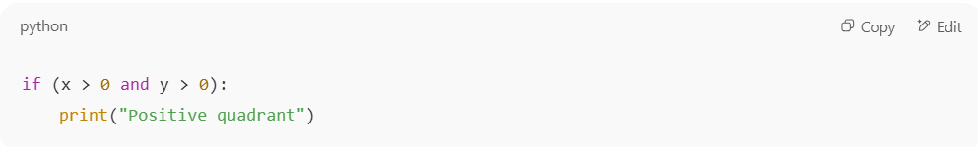
if (x > 0 and y > 0):
print("Positive quadrant")

- This decision has two conditions:
  - x > 0
  - y > 0
👉 Decision Testing would require only two test cases:
- Case A: x=1, y=1 → decision True
- Case B: x=-1, y=1 → decision False
👉 Condition Testing requires each condition to be tested as True and False at least once:
- x > 0 → True (x=1), False (x=-1)
- y > 0 → True (y=1), False (y=-1)
So we need more combinations than branch testing to fully cover the conditions.

📊 Formula for Condition Coverage:
# Source: Chatgpt (GPT-5-Standard) at [8/16/2025]
Condition Coverage (%)=Number of condition outcomes executedTotal number of condition outcomes×100\text{Condition Coverage (\%)} = \frac{\text{Number of condition outcomes executed}}{\text{Total number of condition outcomes}} \times 100

✅ Why is it stronger than Decision Testing?
# Source: Chatgpt (GPT-5-Standard) at [8/16/2025]
- Decision Testing: Only checks the final True/False outcome.
- Condition Testing: Ensures that each atomic condition inside the decision is tested in both states.
👉 Example where decision coverage = 100% but condition coverage < 100%:
if (x > 0 or y > 0):
print("Valid")

- Test cases:
  - x=1, y=0 → decision True
  - x=0, y=0 → decision False
This gives 100% decision coverage.
But condition y > 0 was never True, so condition coverage < 100%.

⚖️ Advantages:
# Source: Chatgpt (GPT-5-Standard) at [8/16/2025]
- Detects logical errors inside compound conditions.
- Stronger than both statement and decision coverage.

⚠️ Limitations:
# Source: Chatgpt (GPT-5-Standard) at [8/16/2025]
- Does not test all possible combinations of conditions (that’s Multiple Condition Coverage).

✅ In short:
Condition Testing makes sure that every individual boolean condition in a decision is tested as True and False, not just the overall decision outcome.

